1. What is UP and DOWN Counter? Explain both with ladder diagram, address and Instruction bits?

* 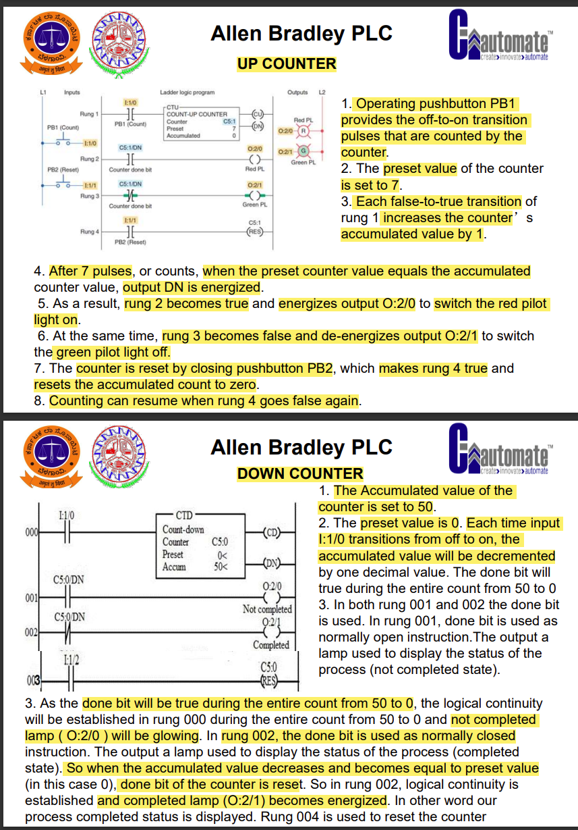

1. What is OSR and OSF Counter? Explain both ?

* 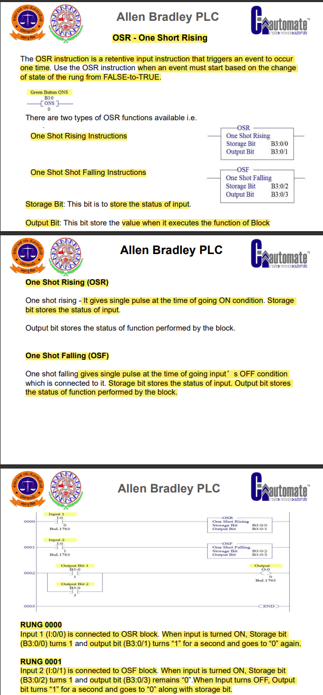

1. What are the different types of Comparison Instructions? Explain any two with instruction diagram & address?
2. What is Move function block, Explain with ladder diagram?

* 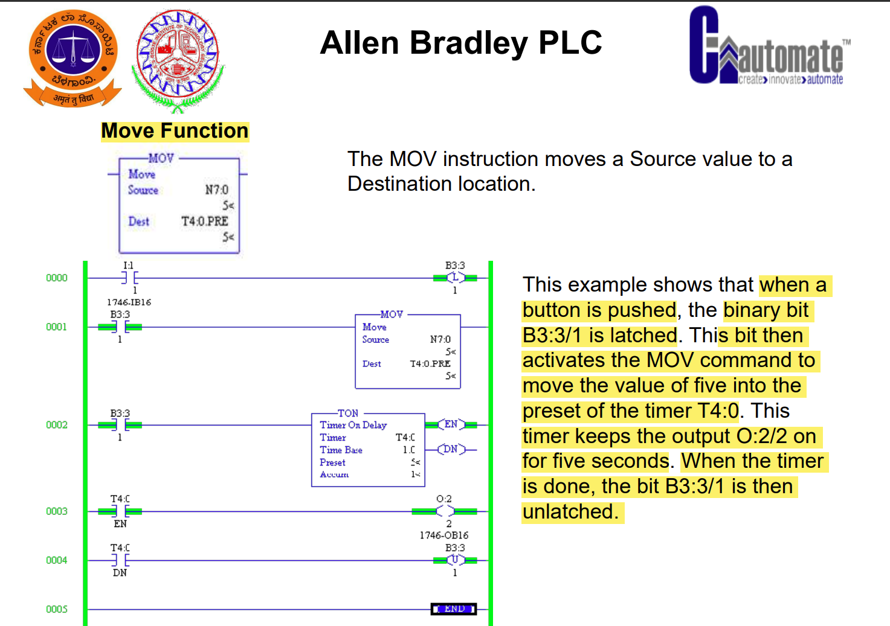

1. Write the PLC Ladder programme for Direct ON Line (DOL) Starter with addressing and names?

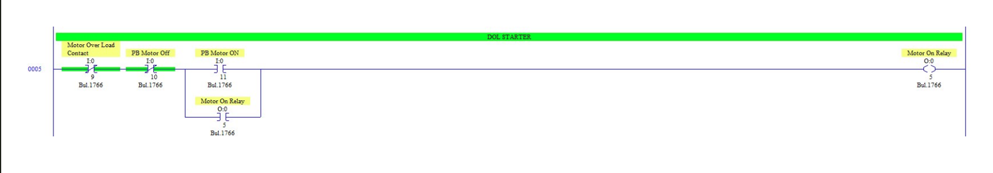

1. Write the Ladder program for Single Way Traffic Signal Control
   1. Start the single way traffic signal cycle by pressing Start Push Button
   2. Red Light gets ON,Timer 1 for 30 Seconds to Stop.
   3. Yellow Lights ON, Timer 2 ON for 5 Seconds To Ready.
   4. Green Lights ON, Timer 3 ON for 25 Seconds to GO.
   5. Continue the cycles as per the above sequence till we press the Emergency OFF or Stop Push Button.

* 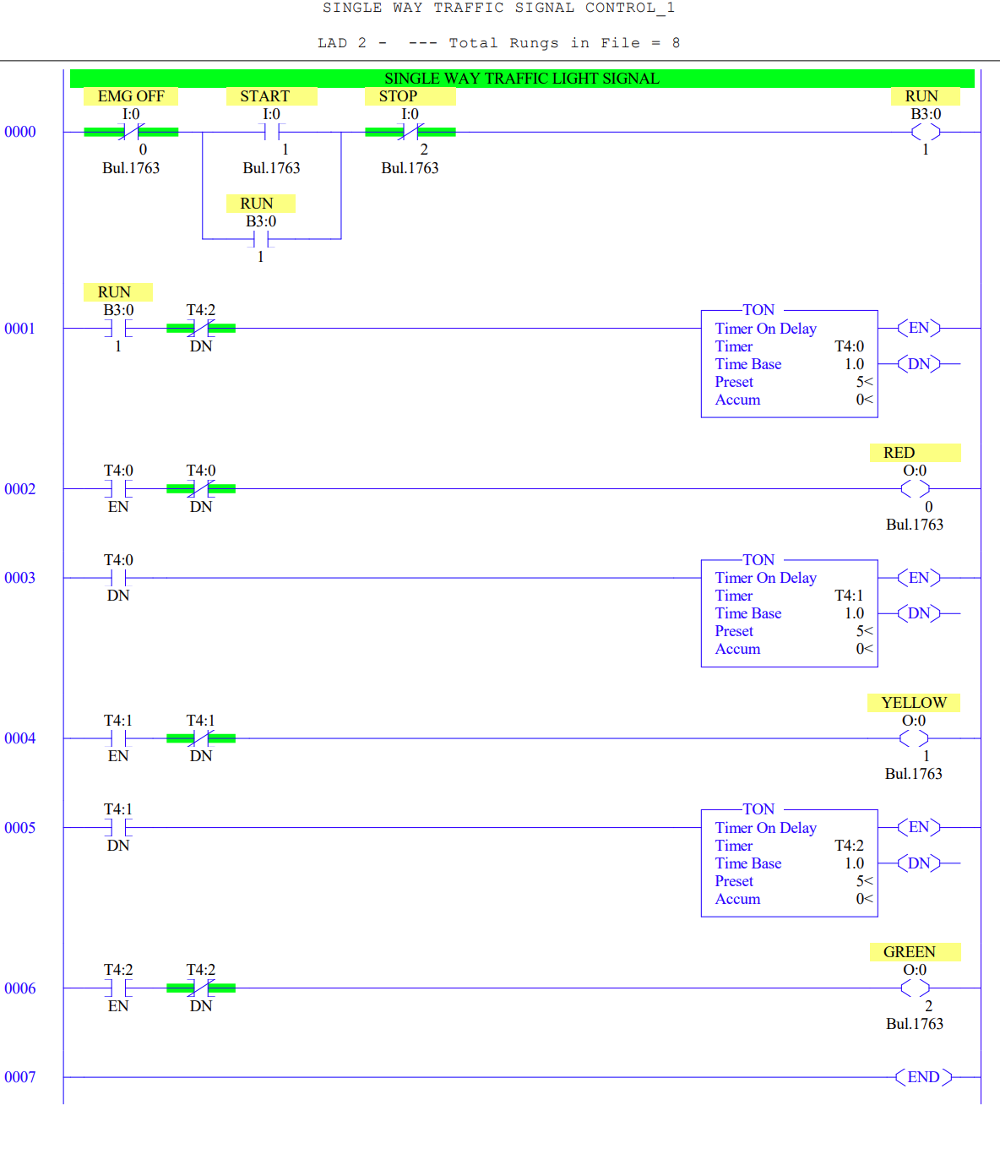

1. What are the different types of SCADA Systems ? Explain all ?

* 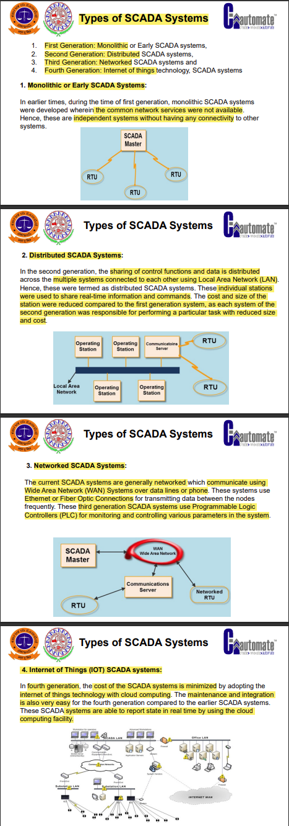

1. Explain SCADA tags ?

* 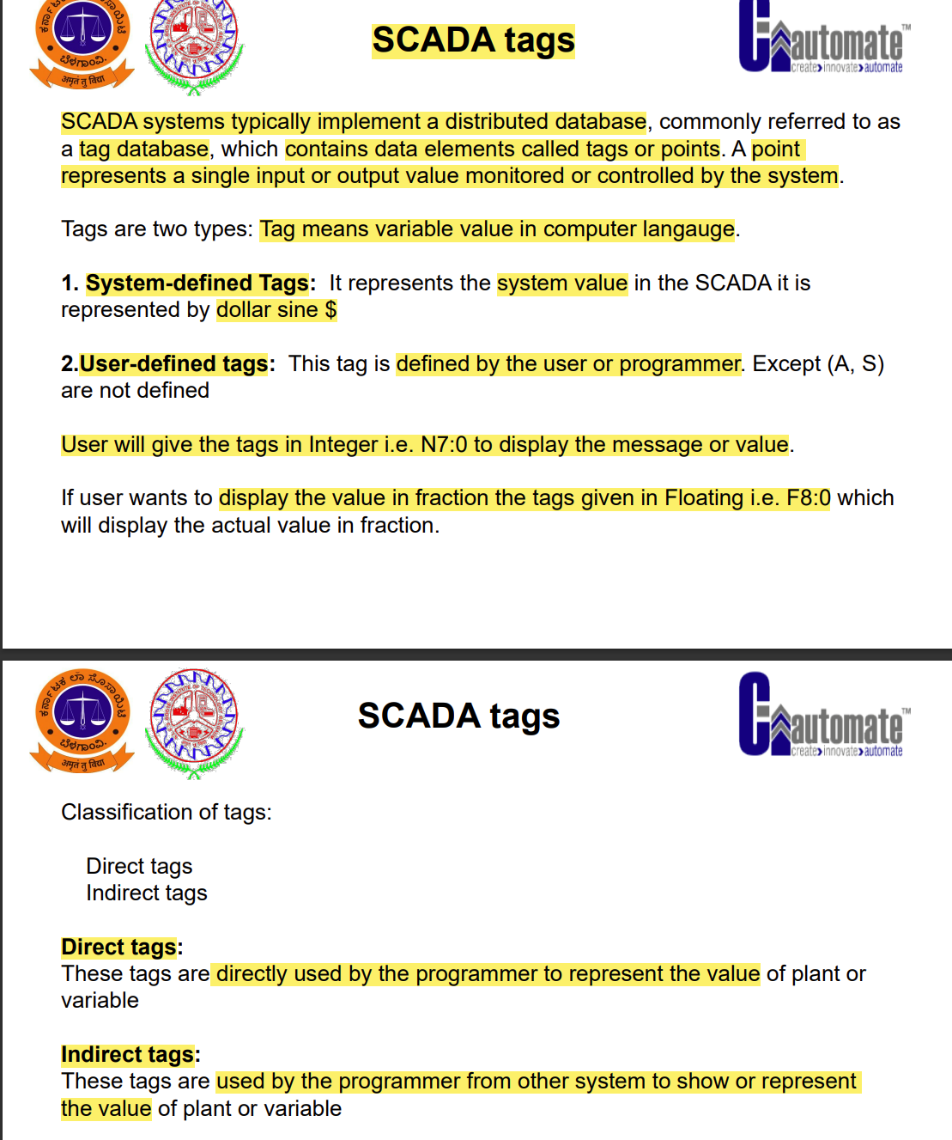

1. Write PLC Programme for below Diagram?
   1. Motor ON & OFF using Start and Stop push button (DOL starter)
   2. Motor ON - Low Level Switch Trip
   3. Motor OFF - High Level Switch Trip

* 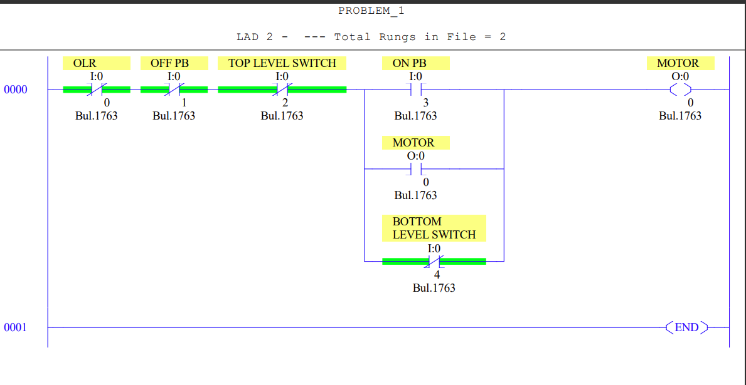

1. Explain Latch and Unlatch Blocks using ladder ?

* 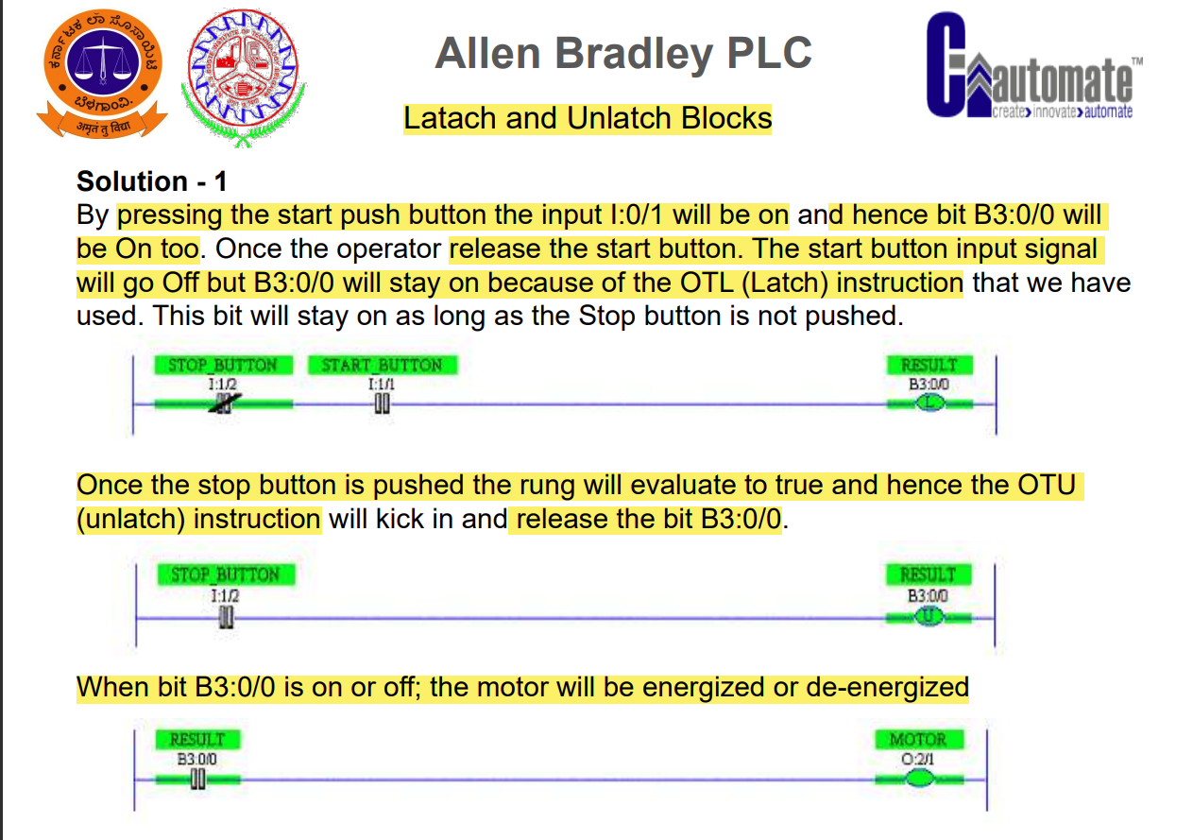

1. Write the PLC Programming Motors logic for the following problem.
   1. There are three motors (M1, M2 & M3), having a separate start and stop push button.
   2. M1 must be running before starting of M2 and M3 motor.
   3. M2 and M3 can start and stop without affecting M1 operation.
   4. Only two motors can run at the time. Starting of the third motor will shut down all the outputs immediately irrespective of its input.

* 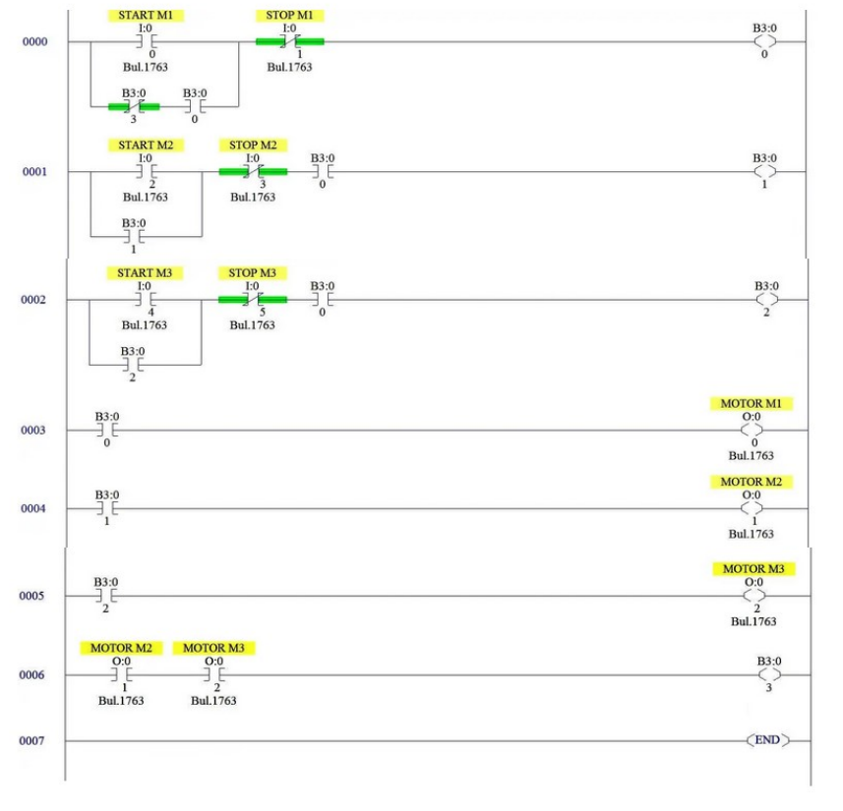

1. Write the PLC Programme,
   1. There are three mixing device motor in processing line A, B, C.
   2. After the process begins mixer A is to start
   3. After 15 seconds of starting mixer A next mixer B is to start
   4. After 10 seconds of starting mixer B next mixer C to start.
   5. The entire mixer to stop after pressing master switch.
2. Explain SCADA briefly with meaning of S, C and DA? What are the types/generation of SCADA?

* 